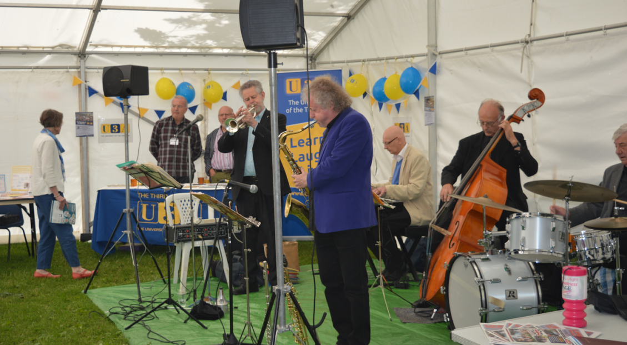

Jazz in the Marquee  
With Teddy Fullick and his Band  
Bar and light refreshments available  
Saturday 1st July 2pm - 4pm   
at St James Campus, Marshall Hill Drive  
We're hoping to build on the success of last year, so  
come along, have a drink in the sun, whilst listening to

Teddy and the boys

